LESSON PLAN BY FEDERICA BIGLINO
Italian maths and science teacher of secondary school lower grade.

TITLE: BUONANCY AND ARCHIMENDES’ PRINCIPLE

GOALS
Learning the properties of volume, mass and density, the interaction between objects properties and fluids density, the Archimedes’ Principle.

MINIMUM REQUIREMENT
Pupils should know: the different between mass and weight, the concept of volume and what is a force.

PUPILS AGE: 11 - 13

STEP 1: discover the density
Time: 1 h
Location: Computer room.

- The teacher starts a discussion asking to the class a simple question: “is it more heavy 1 kg of lead or 1kg of feathers?”
It could happen that the first answer will be “the lead”, but usually some pupils disagree with that answer and the discussion take place.
It is responsibility of the teacher guide the pupils to understand what is the difference between 1kg of lead and 1 kg of feathers; the volume occupied.
- After the discussion the teacher could introduce a new physical quantity: the Density as a ratio between Mass and Volume. It could be interesting remember the difference between a direct quantity and a derivate quantity.
- The teacher have to remember to show the meaning of the unit of measurement: g/cm³ and kg/dm³.
- Go-lab: splash simulation - click the following link
http://go-lab.gw.utwente.nl/production/splash/labs/splash/virtual.html

Exercise 1:
- Moving the density value until you’ll find the density of cork.
- What is cork density quantity? …………………………
- What is the mass of 250 cm³ of cork? ………………………….

Exercise 2:
- Click on the second object.
- Moving the density value until you’ll find the density of aluminium.
- When you change the density what does it happen to the object? What can you see?
- What is Aluminium density quantity? …………………………
- What is the mass of 250 cm³ of aluminium? …………………………

Exercise 3:
- Click on the third object.
- Moving the density value until you’ll find the density of birch and watch what happens to the graph.
- What is birch density quantity? …………………………
- What is the mass of 250 cm³ of birch? …………………………

- With equal volume what is the object with more mass? What does it mean?

Exercise 4: (that part could be explain also by the teacher)
- Delete all and add three new objects with three different densities: the first one with a density less than 1, the second one with a density equal to one and the third one with a density more than 1.
- What is the graph with more slope? And with less slope?
- Moving mass value you try to understand why does the slope change?
- What is the object that first gets the maximum volume? And the last?
- How the three objects reach the maximum volume? Why?
- …………………………………………………..

Verbalization
At the end of the exercises pupils have to write a definition of density; using their words they have to explain what the different in density means among the objects.

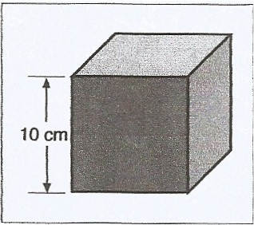
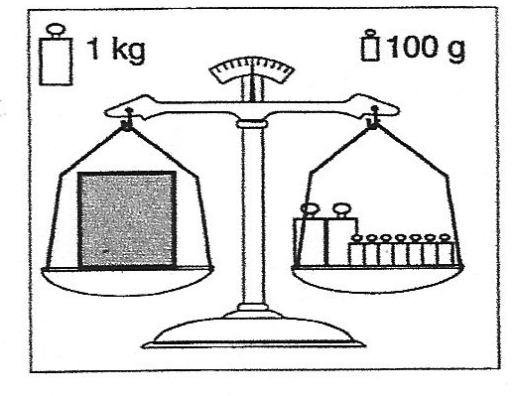
Homework:
Exercises: (one example)
Calculate the volume of the aluminium cube
V = ________________ cm³
Calculate the mass of the cube:
M = ________________ g
Calculate the density of the aluminium cube:
$ρ=\frac{…}{…}= __________\frac{g}{{cm}^{3}}$

STEP 2: FLOATING AND SINKING AND RELATIVE DENSITY
Time: 1 h
Location: classroom or science lab with the possibility to use a computer and a projector.

Experience 1:
Teacher guides pupils to understand floatation and sinking.

Materials:
- 2 equal pieces of aluminium sheets.
- 1 pieces of cork.
- 1 stone.
- A piece of plastiline.
- A piece of wax.
- ……. Something else.
- A can or any other container with water.

With this experience pupils have to say what are the objects that floating and what sinking and why. It’s important that they speak about the relation between the objects and fluid density.

Teacher can start a reflection using aluminium sheets. The aluminium density is more than water density but the rolled-up sheets floats. Why?
After that teacher presses one aluminium ball, with a nutcracker, until all the air inside the ball will be go out. The ball into the water should sink. Why?
What is change? What doesn’t?

Experience 2:
Teacher guides pupils to learn relative density.

Materials:
- 3 glass cans with respectively water, alcohol and oil.
- 3 equal wax pieces.
- 3 cans empty.

Teacher asks to pupils, which will be the wax behaviour into the different fluids. After the discussion teacher will show what happens and guides pupils to understand relative density.

In order to consolidate what has been learned it is useful to show that oil floats into water but sinks into alcohol and try also to make that:

Go - lab simulation: splash
After lab experiences teacher can show the concept learned with more points of view with splash lab simulation and ask to pupils to make some exercises at home or the next time in computer room.

STEP 3: ARCHIMEDES’ PRINCIPLE
Time: 1 h
Location: computer room

Experience 1:
Teacher guides pupils to learn that an object into the water move a volume of water.

Materials:
- Splash simulation.
- 2 equal pieces of plastiline.
- 2 graduated can of water

Using splash simulation teacher shows to pupils the unlike displaced volume by an object that floats or sinks.

In a second time teacher can show that a ball of plastiline sinks, but if you model the plastiline as a boat it will float. Why?
It is important to show the unlike of displaced volume and that the plastiline boat displaces more volume than the plastiline ball (the real plastiline volume).

Experience 2:
Teacher guides pupils to learn Archimedes’ principles.

Materials:
- Splash simulation.

- Teacher shows to pupils that an object that floats displaces a volume of water equal to its weight compared to weight of displaced volume by another object that sinks. The weight of displaced volume is the buoyant force.
- It is important to learn that the quantity that takes place in Archimedes’ principle is the volume and not the mass. So using splash teacher can make 2 different objects with same volume and show that they receive the same buoyant force. In a second time teacher changes the volume of the 1 objects and shows the diversity of the buoyant force.
- Calculate by splash the weight of the portion of the object that rest out of the water as a difference between the weight of the object and the weight of the displaced volume of water. That is the difference in density.
- Pupils should make same exercises through splash.
- Pupils have to verbalize the Archimedes’ principle.

And that’s all!
In this lesson plan I haven’t used many formula or demonstration because I think it wouldn’t helpful to my pupils. For me, in my level of school, if they can explain a concept and show that they have understood what they have learned it will be enough.

Thanks

Federica

